**Question 1**

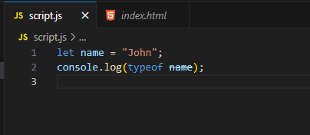

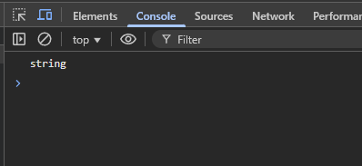

**Question 2**

**Which of the following is a JavaScript primitive type?  
Answer: c) Number**

**Question 3**

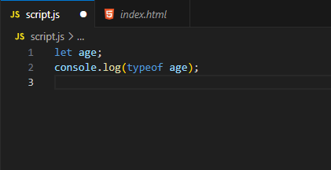

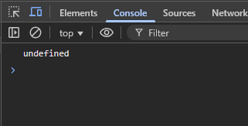

**Question 4**

**How do you access the first element of an array in JavaScript?  
Answer: c) array[0**

**Question 5**

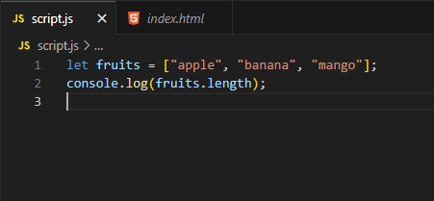

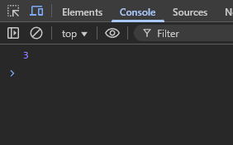

**Question 6**

**Which method is used to add an item at the end of an array?  
Answer: a) push()**

**Question 7**

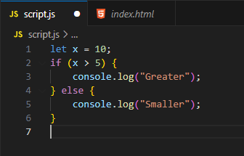

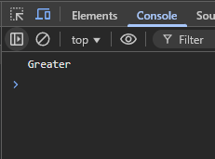

**Question 8**

**Which symbol is used for 'equal to' in a conditional statement?  
Answer: d) Both b and c (== and ===)**

**Question 9**

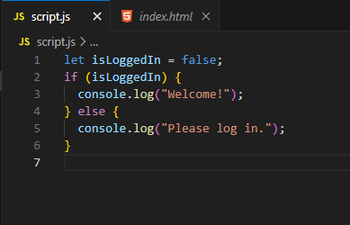

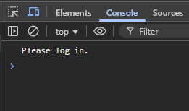

**Question 10**

**How do you check if a variable num is exactly equal to 100 and is a number type?  
Answer: c) if (num === 100 && typeof num === "number")**

**Question 11**

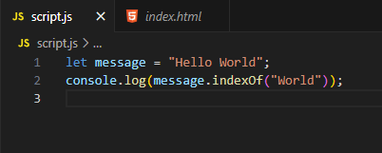

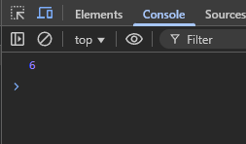

**Question 12**

**Which method splits a string into an array using a specific separator?  
Answer: a) split(**

**Question 13**

**What does the splice() method do in arrays?  
Answer: c) Can add and remove items**

**Question 14**

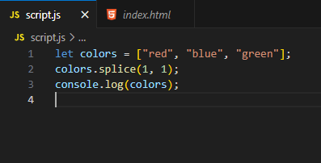

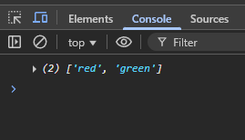

**Question 15**

**How can you join an array into a single string separated by commas?**

**Answer: d) Both b and c**

**Question 16**

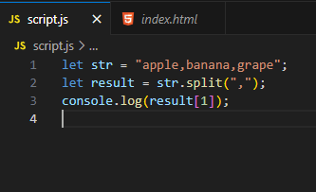

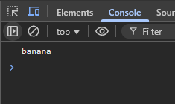

**Question 17**

**Which method checks if an array contains a certain value?  
Answer: b) includes()**

**Question 18**

**What does indexOf() return if the element is not found?  
Answer: d) -1**

**Question 19**

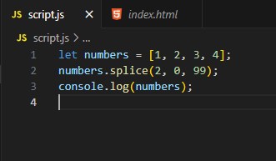

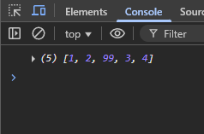

**Question 20**

